GUI application
The goal of this application is to aid visualization of the play of a particular AI.
To run: BlokusGUIapp.java
The playfield will appear. Click the ‘Next Move’ button at the bottom of the window to have the players play their pieces. Each play will be placed on the board, and the move will be displayed in the console window. When there are no more moves, the game ends, and the score is displayed, as shown below.
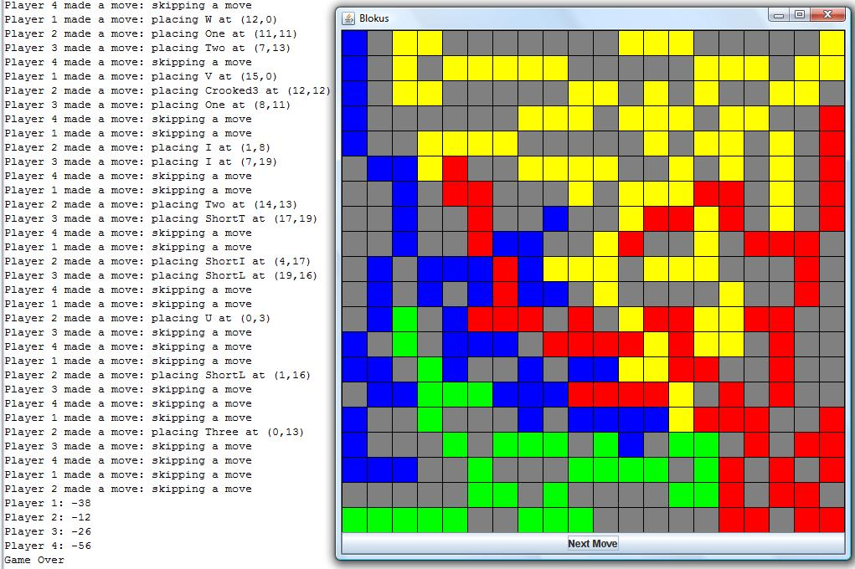
This screenshot shows both the console window and the GUI window.
To change AIs:
AIs are assigned in the start() method. The following AIs are available:
AI | Parameters
AIRandom() | None
AILikesMiddle() | None
AImidBlocksCorners(M, B, C) | M: Weight placed on the middle factor (positive int)  B: Weight placed on the blocks factor (positive int)  C: Weight placed on the corners factor (positive int)
AILookAhead(G) | G: the game, in all cases _game

Statistics application
The goal of this application is to run multiple games and present average scores. It automated our data collection efforts.
To run: BlokusAutoRunner.java
This application outputs to the console window. It will display the current game it is running. When it reaches the end of the run it will display average scores, as well as min and max scores. Here is a portion of a sample run.
Now running game 99 of 100
Completed game #99
Now running game 100 of 100
Completed game #100
score for Player1 (Middle preference AI) -35.32
score for Player2 (Mid/blocks/corners AI, M15, B10, C10) -14.76
score for Player3 (Random AI) -37.8
score for Player4 (Random AI) -43.79
Averaged over 100 games
The best score was 20 by Mid/blocks/corners AI, M15, B10, C10
The worst score was -64 by Random AI
To change AIs:
AIs are assigned in the start() method. The following AIs are available:
AI | Parameters
AIRandom() | None
AILikesMiddle() | None
AImidBlocksCorners(M, B, C) | M: Weight placed on the middle factor (positive int)  B: Weight placed on the blocks factor (positive int)  C: Weight placed on the corners factor (positive int)
AILookAhead(G) | G: the game, in all cases _game

To change the number of games in the run, modify the int gamesToPlay variable. Note that that runs of 250 games or less are recommended to prevent out of memory errors.

